RISK ASSESSMENT FOR: | Allergies |  | 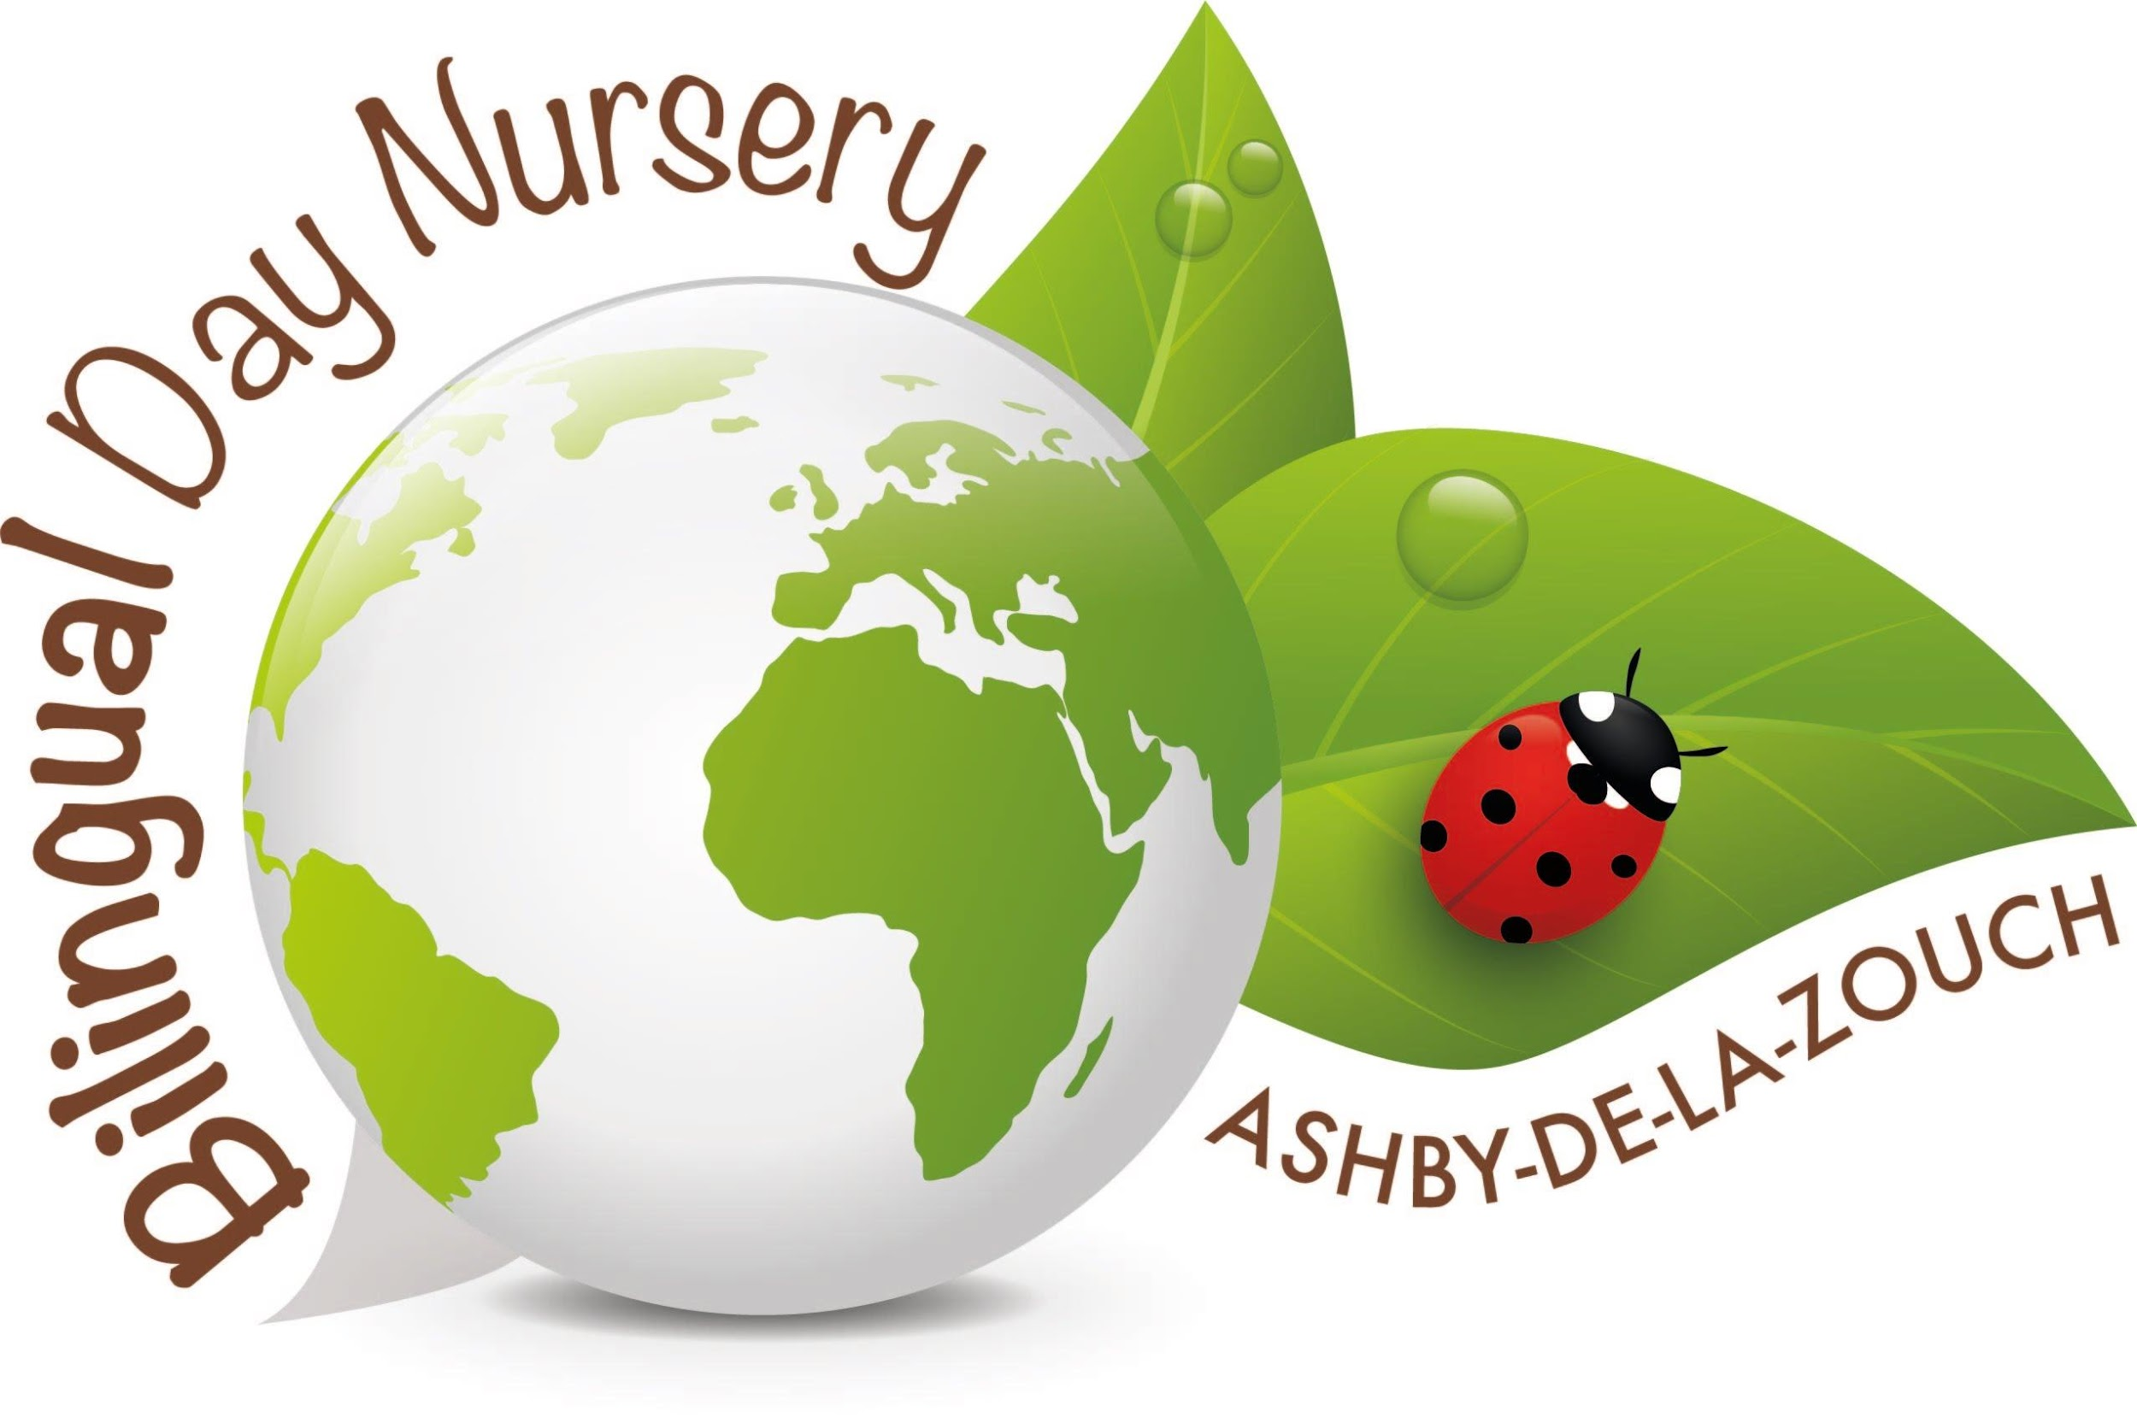
Establishment:  Bilingual Day Nursery | Assessment by:  Rachel Barsby-Robinson | Date: 14/01/19

Hazard / Risk | Who is at Risk? | How can the hazards cause harm? | Normal Control Measures | Are Normal Control Measures Y/N/NA |  | Risk Level (L/M/H/VH)
 |  |  |  | In Place | Adequate
 | Staff, children and visitors |  |  | Yes | Yes
Objects or Equipment to Consider
Food at mealtimes | Staff, children and visitors | Allergic reaction to something that they digest. | Overseeing when food is served to check the correct children, staff and visitors get the correct food that they will not have a reaction too. Making sure plates are properly washed. | Y | Y | M
Bee sting | Staff, children and visitors | Reaction to the sting | Cold compress and observing their reaction. Ring parents to inform them and any changes in their normal behaviour ring 999 for an ambulance if it is serious. | Y | Y | M
Nettle sting | Staff, children and visitors | Reaction to the sting | Cold compress and observing their reaction. Ring parents to inform them and any changes in their normal behaviour ring 999 for an ambulance if it is serious. | Y | Y | M
Insect bite | Staff, children and visitors | Reaction to the bite | Cold compress and observing their reaction. Ring parents to inform them and any changes in their normal behaviour ring 999 for an ambulance if it is serious. | Y | Y | M
Preparing food | Staff, children and visitors | Allergic reaction to something that they digest. | Checking packaging when preparing food. No cross contamination during food pre, washing hand between touching food someone could be allergic too. | Y | Y | M
Drinks | Staff, children and visitors | Allergic reaction to something that they digest/ touch. | Overseeing when drinks are out, especially milk, and check the correct children, staff and visitors are aloud it. Making sure cups are washed properly. | Y | Y | M

Additional Control Measures  (to take account of local/individual circumstances including changes such as working practices, equipment, staffing levels). | Action by Whom  (list the name of the person/people who have been designated to conduct actions) | Action by When  (set timescales for the completion of the actions – remember to prioritise them) | Action Completed  (record the actual date of completion for each action listed) | Residual Risk Rating
DATE OF REVIEW:  Record actual date of review  04/05/2020 | COMMENTS:  Record any comments reviewer wishes to make. Including recommendations for future reviews.
DATE OF  REVIEW: | COMMENTS:
DATE OF  REVIEW: | COMMENTS:

RESIDUAL RISK RATING | ACTION REQUIRED
VERY HIGH (VH) Strong likelihood of fatality / serious injury occurring | The activity must not take place at all.  You must identify further controls to reduce the risk rating.
HIGH (H) Possibility of fatality/serious injury occurring | You must identify further controls to reduce the risk rating.  Seek further advice, e.g. from your H&S Team
MEDIUM (M) Possibility of significant injury or over 3 day absence occurring | If it is not possible to lower risk further, you will need to consider the risk against the benefit. Monitor risk assessments at this rating more regularly and closely.
LOW (L) Possibility of minor injury only | No further action required.

