RISK ASSESSMENT FOR: | Exchanging videos with a Spanish school |  | 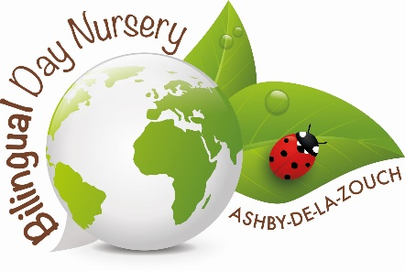
Establishment:  Bilingual Day Nursery | Assessment by:  Queralt Faura Casadella | Date: 12/03/19

Hazard / Risk | Who is at Risk? | How can the hazards cause harm? | Normal Control Measures | Are Normal Control Measures Y/N/NA |  | Risk Level (L/M/H/VH)
 |  |  |  | In Place | Adequate
Video getting shared | Children and their families | Breach of Safeguarding policy and GDPR. Children who are high risk such as adopted may have been identified which could be harmful to their wellbeing and safety | - Every time that a video is sent, it is checked which children have the authorisation to participate in the video exchange with the Spanish school and it is ensured that they do not appear, even in the background or in a name tag.  - The English teacher of the Spanish school was asked to sign and statement where his name and surname appear, and where he agreed not to share the video or use it for purposes that were not educational. | Yes | Yes | L
Logo being shown | Children and their families |  | - Every time that a video is recorded, any child wearing the nursery uniform does not appear or something is put on top of her/him to make sure that the logo does not appear in the video. | Yes | Yes | L
Video being watched by external people (not the teachers of the Spanish school) | Children and their families | Breach of Safeguarding policy and GDPR. Children who are high risk such as adopted may have been identified which could be harmful to their wellbeing and safety | - The English teacher of the Spanish school was asked to sign, and statement where his name and surname appear and where he agreed not to share the video or use it for purposes that were not educational. | Yes | Yes | L
A photo with a child’s name appearing int the video | Children and their families | Breach of Safeguarding policy and GDPR. Children who are high risk such as adopted may have been identified which could be harmful to their wellbeing and safety | - Every time that a video is sent, it is checked which children have the authorisation to participate in the video exchange with the Spanish school and it is ensured that they do not appear, even in the background or in a name tag | Yes | Yes | L
Objects or Equipment to Consider

Additional Control Measures  (to take account of local/individual circumstances including changes such as working practices, equipment, staffing levels). | Action by Whom  (list the name of the person/people who have been designated to conduct actions) | Action by When  (set timescales for the completion of the actions – remember to prioritise them) | Action Completed  (record the actual date of completion for each action listed) | Residual Risk Rating
DATE OF REVIEW:  Record actual date of review  30/09/2020 | COMMENTS:  Record any comments reviewer wishes to make. Including recommendations for future reviews.
DATE OF  REVIEW: | COMMENTS:
DATE OF  REVIEW: | COMMENTS:

RESIDUAL RISK RATING | ACTION REQUIRED
VERY HIGH (VH) Strong likelihood of fatality / serious injury occurring | The activity must not take place at all.  You must identify further controls to reduce the risk rating.
HIGH (H) Possibility of fatality/serious injury occurring | You must identify further controls to reduce the risk rating.  Seek further advice, e.g. from your H&S Team
MEDIUM (M) Possibility of significant injury or over 3 day absence occurring | If it is not possible to lower risk further, you will need to consider the risk against the benefit. Monitor risk assessments at this rating more regularly and closely.
LOW (L) Possibility of minor injury only | No further action required.

