RISK ASSESSMENT FOR: | Choking |  | 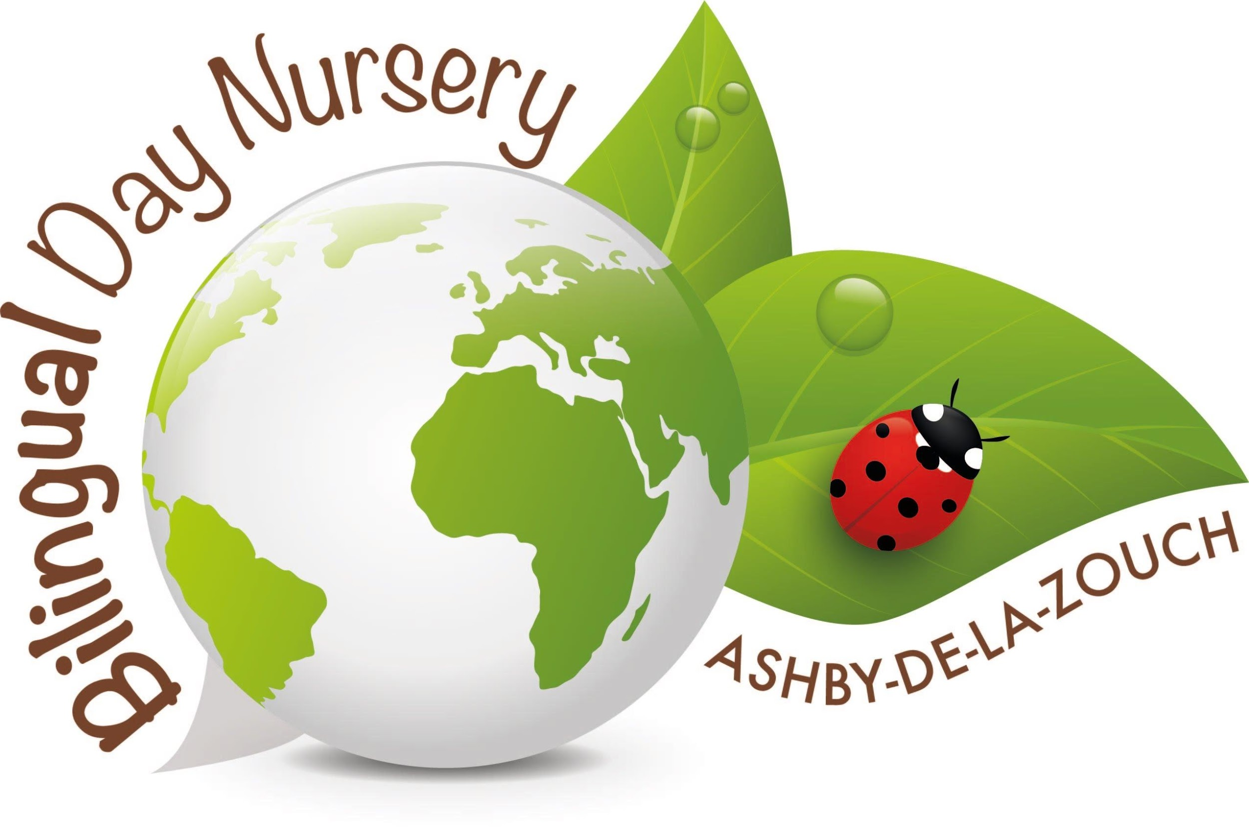
Establishment:  Bilingual Day Nursery | Assessment by:  Rachel Barsby-Robinson | Date: 14/01/19

Hazard / Risk | Who is at Risk? | How can the hazards cause harm? | Normal Control Measures | Are Normal Control Measures Y/N/NA |  | Risk Level (L/M/H/VH)
 |  |  |  | In Place | Adequate
 | Staff, children and visitors |  |  | Yes | Yes
Objects or Equipment to Consider
Corks | Children | Chewing and chocking the cork | Choke test for babies, closely watched when children are playing with them. Telling children not to put them in their mouths | Yes | Yes | L
Pens/pencils | Children | Chewing and chocking the pen/pencils | Only using them when supervised. Encouraging children not to put them in their mouth/ chew on them. | Yes | Yes | L
Pen lids | Children | Chewing and chocking the pen lids | Taking the pen lids away from babies. Supervised use of the pen lids when the pens are being used. | Yes | Yes | L
Screws | Children | Chewing and chocking the screws | Checking equipment at the beginning and throughout the day. Record it on the daily risk assessment. If any screws are loose/come out screw them back in. Remove screws that are dangerous. If noticing screws are missing, look for it until it is found. Check the CCTV. | Yes | Yes | L
Rubbers/erasers | Children | Chewing and chocking the rubbers/erasers | Use rubbers/erasers supervised. Ensuring they do not put them in their mouth and chew on it. | Yes | Yes | L
Milk tops | Children | Chewing and chocking the milk tops | Babies not having access to milk tops. Supervise the older children when undoing the milk or playing with milk tops. | Yes | Yes | L
Beads/sequins/pompoms | Children | Chewing and chocking the beads/sequins/pompoms | Supervised contact when using beads/sequins/pompoms. Avoid children putting them in their mouths. Sweeping the floor and cleaning the table after use so babies do not pick them up and put them in their mouth. | Yes | Yes | L
Food | Children | Chewing and chocking the food | Sitting with the children at mealtimes and observing them while they are eating. Making sure children are sitting down when they are eating and not wandering around the house. Cutting babies food up if they are unable to bite pieces off. | Yes | Yes | L
Shells | Children | Chewing and chocking the cork | Doing chocking test before the babies use the shells. Observe the children using the shells and disguarding any broken pieces. | Yes | Yes | L
Pine cones | Children | Chewing and chocking the cork | Doing chocking test before the babies use the pine cones. Observe the children playing with the pinecones and disguarding any broken pieces. | Yes | Yes | L
Stones (outside) | Children | Chewing and chocking the cork | Discouraging babies from picking the stones up and bring them toward their mouths. If the babies are playing outside watching them carefully when they are on the floor. | Yes | Yes | L
Leaves | Children | Chewing and chocking the cork | Discouraging babies putting the leaves in their mouth. Watching babies closely when they are exploring outside. | Yes | Yes | L
Plastic animals | Children | Chewing and chocking the cork | Watching children when they are playing with plastic animals and watching they do not chew pieces/ breaking pieces off. Disguarding broken pieces. | Yes | Yes | L

Additional Control Measures  (to take account of local/individual circumstances including changes such as working practices, equipment, staffing levels). | Action by Whom  (list the name of the person/people who have been designated to conduct actions) | Action by When  (set timescales for the completion of the actions – remember to prioritise them) | Action Completed  (record the actual date of completion for each action listed) | Residual Risk Rating
DATE OF REVIEW:  Record actual date of review  04/05/2020 | COMMENTS:  Record any comments reviewer wishes to make. Including recommendations for future reviews.
DATE OF  REVIEW: | COMMENTS:
DATE OF  REVIEW: | COMMENTS:

RESIDUAL RISK RATING | ACTION REQUIRED
VERY HIGH (VH) Strong likelihood of fatality / serious injury occurring | The activity must not take place at all.  You must identify further controls to reduce the risk rating.
HIGH (H) Possibility of fatality/serious injury occurring | You must identify further controls to reduce the risk rating.  Seek further advice, e.g. from your H&S Team
MEDIUM (M) Possibility of significant injury or over 3 day absence occurring | If it is not possible to lower risk further, you will need to consider the risk against the benefit. Monitor risk assessments at this rating more regularly and closely.
LOW (L) Possibility of minor injury only | No further action required.

