RISK ASSESSMENT FOR: | Slips and Trips |  | 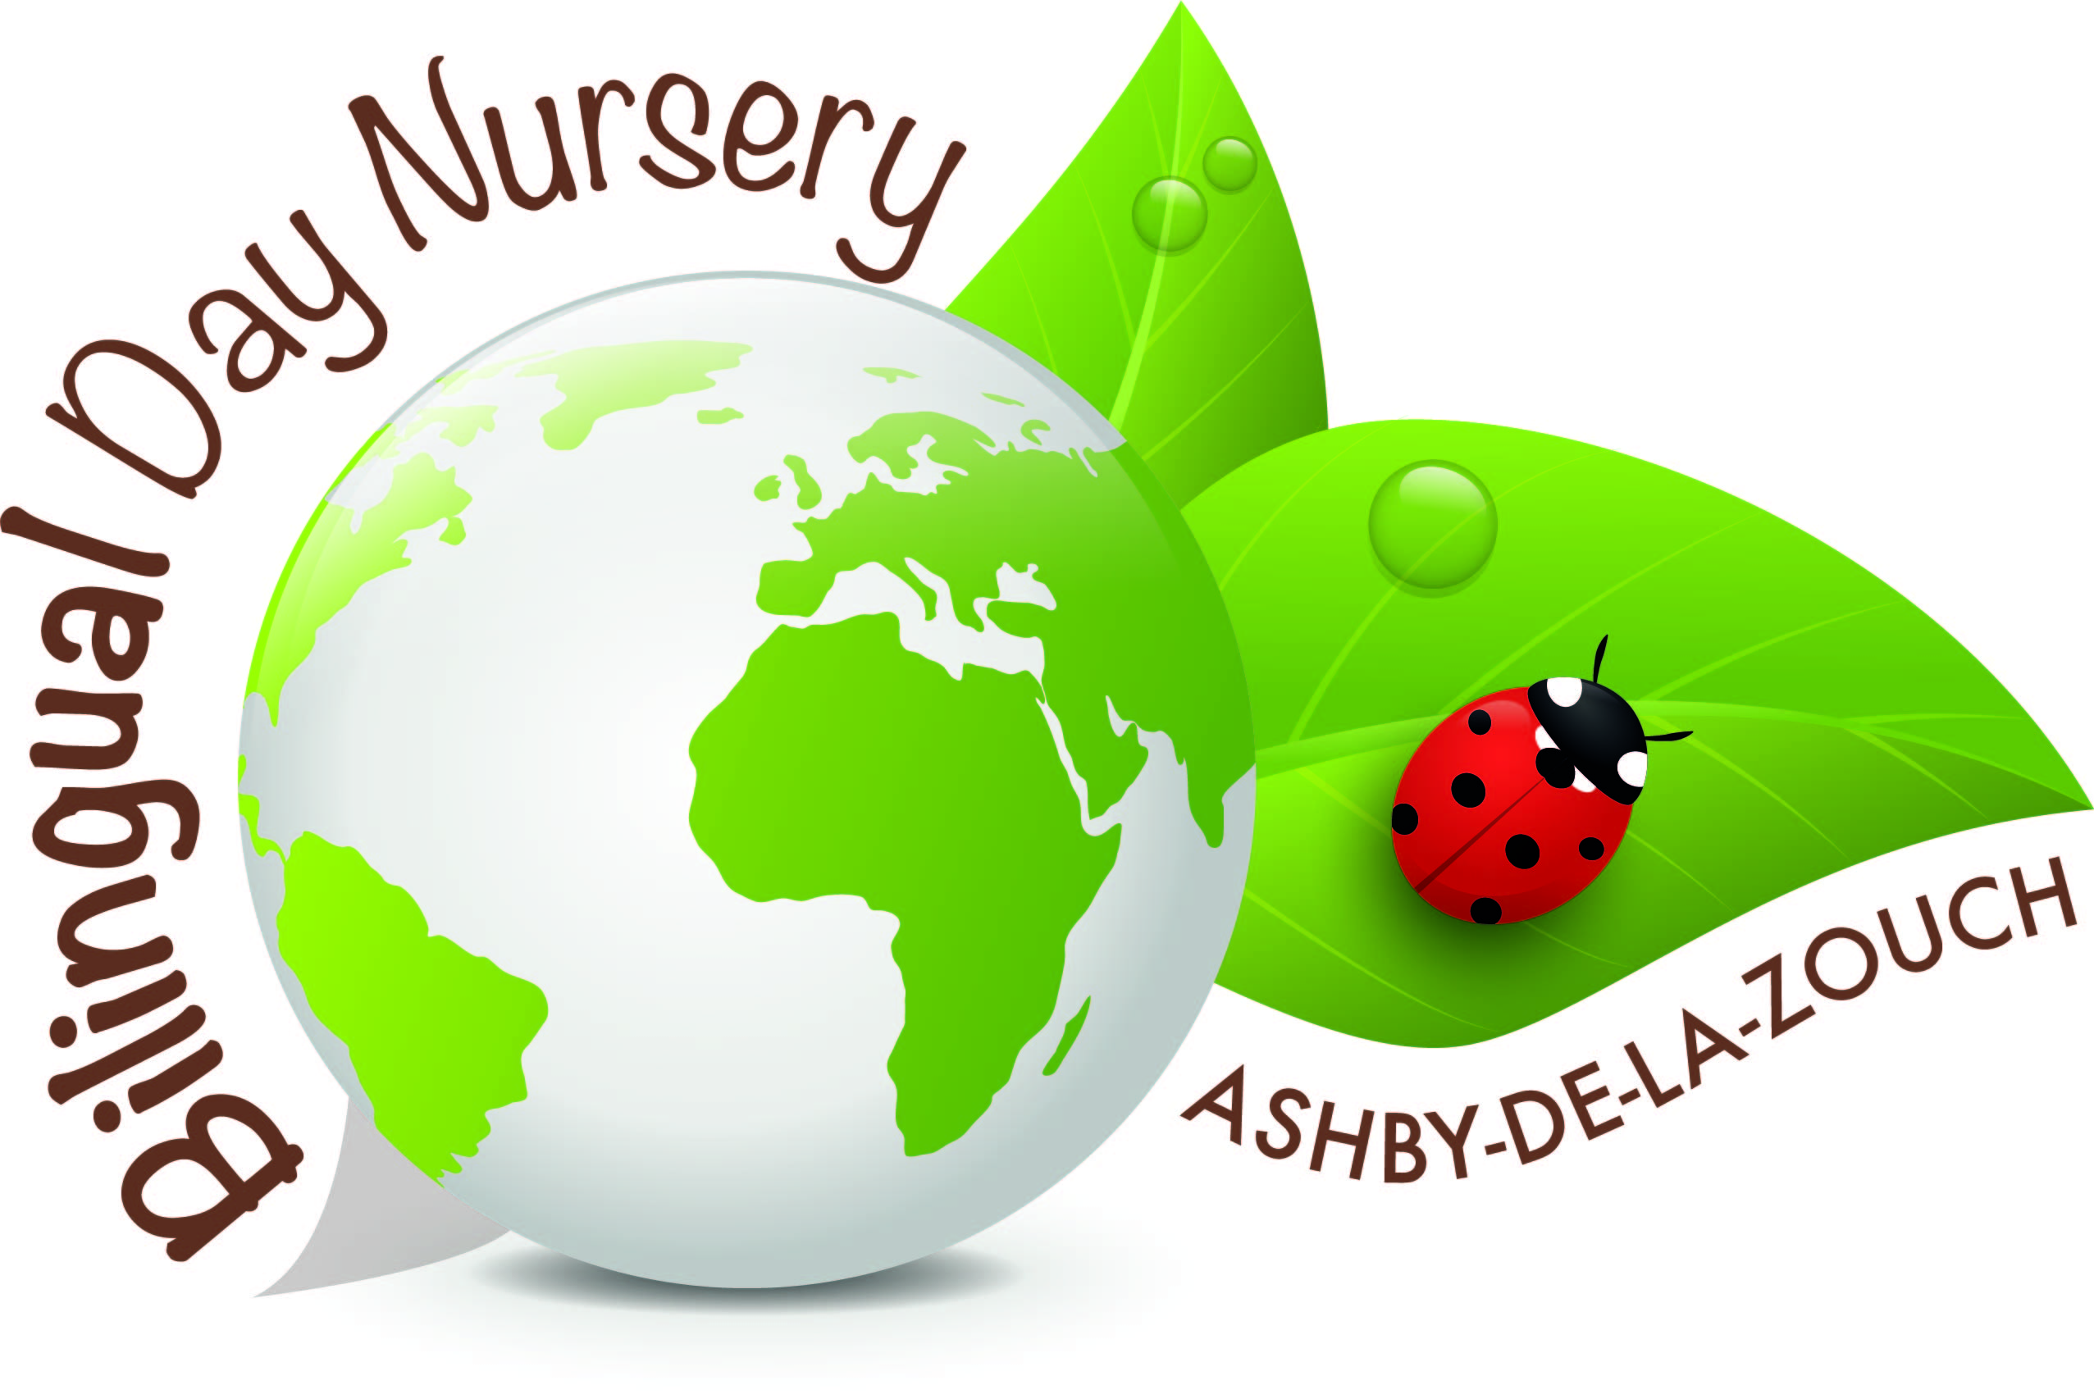
Establishment:  Bilingual Day Nursery | Assessment by:  Rachel Barsby-Robinson | Date: 14/01/19

Hazard / Risk | Who is at Risk? | How can the hazards cause harm? | Normal Control Measures | Are Normal Control Measures Y/N/NA |  | Risk Level (L/M/H/VH)
 |  |  |  | In Place | Adequate
Slips & Trips | Staff, children and visitors | Injured if trip over objects, slip on spillages or fall down stairs, ramps or slopes | Good housekeeping.  • All areas well lit,  • No trailing leads or cables.  • All staff keep work areas clear e.g. no boxes left in walkways, deliveries stored  immediately.  • All rooms cleared and tidied throughout the day and before staff leave.  • Staff levels are to the appropriate ratio to ensure all children are monitored and protected at all times  - Spillages in kitchens or anywhere to be address and rectified immediately. | Yes | Yes
 | Staff, children and visitors | Injured if trip or fall against a hard object or sharp edge | • All furniture is child friendly  • Ratios of staff to children will always be maintained to ensure child supervision is always in place  • Staff levels are to the appropriate ratio to ensure all children are monitored and protected at all times  Daily Checks are in place. | Yes | Yes
Objects or Equipment to Consider
Spilt liquids | Staff, children and visitors | Slip on spillages | Wipe up liquids straight away | Yes | Yes | L
Messy play (sand, shaving foam, ect.) | Staff, children and visitors | Slipping on sand and spreading it from room to room. | Sweep up the messy play/ wipe the floor. Trying to keep it as contained as possible. | Yes | Yes | L
Wooden blocks | Staff, children and visitors | Tripping over them | To tidy them up when the children have finished playing. | Yes | Yes | L
Pine cones , shells | Staff, children and visitors | Tripping over them | To tidy them up when the children have finished playing. | Yes | Yes | L
Chairs | Staff, children and visitors | Tripping over them when left in the middle of the room | To tidy them up when the children have finished eating. Stacking them carefully so they do not fall. | Yes | Yes | L
Musical instruments | Staff, children and visitors | Tripping over them | To tidy them up when the children have finished playing. | Yes | Yes | L
Animals | Staff, children and visitors | Tripping over them | To tidy them up when the children have finished playing. | Yes | Yes | L
Pencils | Staff, children and visitors | Tripping over them | Ensuring they are not on the floor and to tidy them up when the children have finished playing. | Yes | Yes | L
Step going between room | Staff, children and visitors | Tripping over the step | Ensuring you lift your foot correctly and encouraging young children to hold on as they walk through . | Yes | Yes | L
Child gate | Staff, children and visitors | Tripping over | Ensuring you lift your foot correctly and encouraging young children to hold on as they walk through . | Yes | Yes | L
Books and paper | Staff, children and visitors | Tripping over | Clearing away from the floor and putting away when not being used. | Yes | Yes | L
Stones outside | Staff, children and visitors | Tripping over | Sweeping them when on the path and encouraging not to run on the stones | Yes | Yes | L
Water or ice or snow outside | Staff, children and visitors | Slipping | Walk carefully and use salt when there is ice on the path | Yes | Yes | L
Food | Staff, children and visitors | Slipping | Clearing food up from the floor using the dust pan and brush | Yes | Yes | L
Shoes and wellies | Staff, children and visitors | Tripping over | Putting them on the shoe rack or welly rack outside when they are not being used. | Yes | Yes | L
Tepee | Staff, children and visitors | Tripping and slipping over | Walking carefully in and around it | Yes | Yes | L
Stage | Staff, children and visitors | Tripping and slipping over | Walking carefully in and around it | Yes | Yes | L

Additional Control Measures  (to take account of local/individual circumstances including changes such as working practices, equipment, staffing levels). | Action by Whom  (list the name of the person/people who have been designated to conduct actions) | Action by When  (set timescales for the completion of the actions – remember to prioritise them) | Action Completed  (record the actual date of completion for each action listed) | Residual Risk Rating
DATE OF REVIEW:  Record actual date of review  30/09/2020 | COMMENTS:  Record any comments reviewer wishes to make. Including recommendations for future reviews.
DATE OF  REVIEW: | COMMENTS:
DATE OF  REVIEW: | COMMENTS:

RESIDUAL RISK RATING | ACTION REQUIRED
VERY HIGH (VH) Strong likelihood of fatality / serious injury occurring | The activity must not take place at all.  You must identify further controls to reduce the risk rating.
HIGH (H) Possibility of fatality/serious injury occurring | You must identify further controls to reduce the risk rating.  Seek further advice, e.g. from your H&S Team
MEDIUM (M) Possibility of significant injury or over 3 day absence occurring | If it is not possible to lower risk further, you will need to consider the risk against the benefit. Monitor risk assessments at this rating more regularly and closely.
LOW (L) Possibility of minor injury only | No further action required.

