RISK ASSESSMENT FOR: | PLAy Equipment |  | 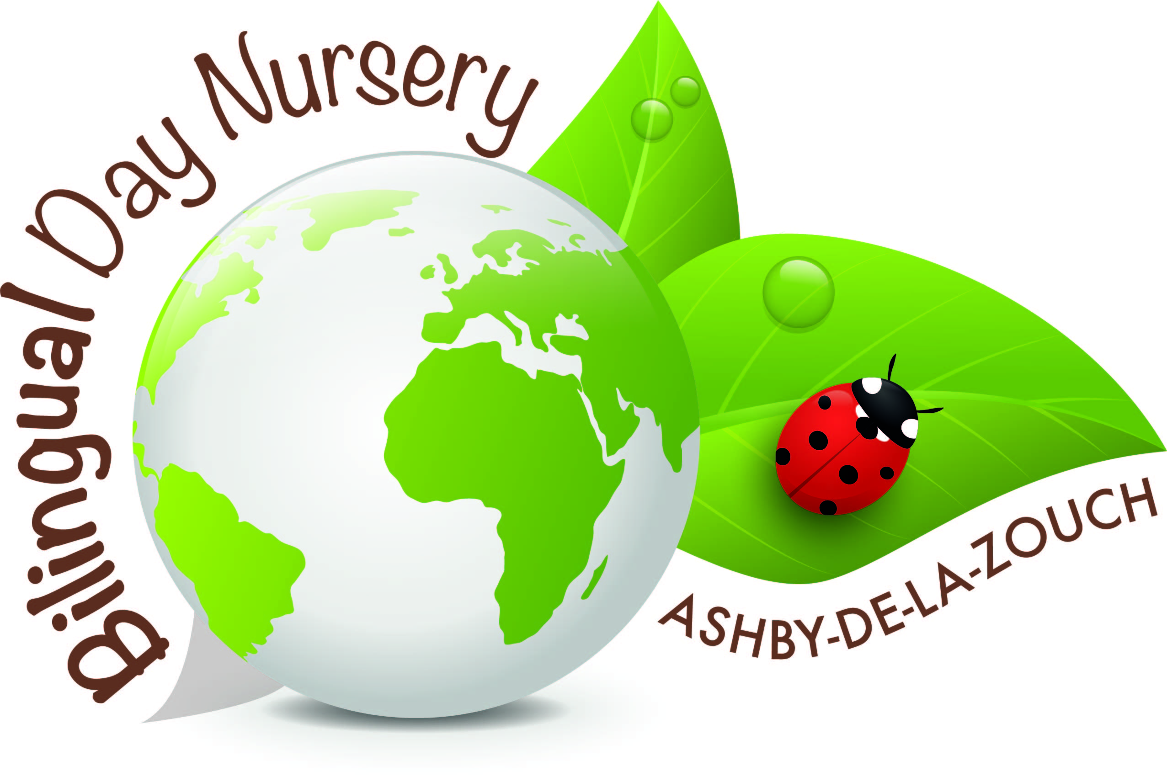
Establishment:  Bilingual Day Nursery | Assessment by:  Rachel Barsby-Robinson | Date: 14/01/19

Hazard / Risk | Who is at Risk? | How can the hazards cause harm? | Normal Control Measures | Are Normal Control Measures Y/N/NA |  | Risk Level (L/M/H/VH)
 |  |  |  | In Place | Adequate
 | Staff, children and visitors |  |  | Yes | Yes
Objects or Equipment to Consider
Chairs | Staff, children and visitors | Tripping and falling | Checking they are safe daily and making sure they are sat on properly | Y | Y | L
Tables | Staff, children and visitors | Tripping and falling | Checking the tables are safe daily. | Y | Y | L
Highchairs | Children | Falling out of them | Someone sitting with them at all times. | Y | Y | L
Wicker baskets | Children | Splinter and choking | Removing broken ones. | Y | Y | L
Carboard tubes/boxes | Children | Tripping and chocking | Removing broken ones. | Y | Y | L
Meditation mats | Staff, children and visitors | Tripping and falling | Tidying away when not being used. | Y | Y | L
Beads sequins pompoms | Children | Choking and tripping | Supervision when being used. | Y | Y | L
Paint and paintbrushes | Children | Choking and tripping | Tidying up after use and removing broken ones. | Y | Y | L
Scissors | Staff, children and visitors | Cutting themselves | Supervising when being used. | Y | Y | L
Pens and pencils and crayons | Children | Choking and tripping | Clearing up after use and supervising when being used. | Y | Y | L
Metal and pot teapots, jugs and bowls | Staff, children and visitors | Trapping fingers, broken pot can cut if anyone picks it up. | Supervision when being used and removing broken pieces carefully. | Y | Y | L
Eating plates (crockery) and utensils | Staff, children and visitors | Cutting someone if the crockery breaks | Carefully removing broken pieces and hovering afterwards | Y | Y | L
Coat pegs | Children | Trapping fingers | Supervision when being used. | Y | Y | L
Elastic bands | Children | Chocking and breaking | Removing broken ones immediately | Y | Y | L
Taps and toilets | Children | Trapping fingers, burning if the water gets too hot. | Supervision when they are being used and checking the hot tap on a regular basis. | Y | Y | L
Shoe racks | Staff, children and visitors | Splinters and cuts if it is broken | Removing if broken and check regularly | Y | Y | L
Pine cones | Children | Choking if broken or small | Removing the broken pine cones and doing the choking test when they are in the baby room. | Y | Y | L
Shells | Children | Choking if broken or small. Can cut if broken | Removing the broken shells and doing the choking test when they are in the baby room. | Y | Y | L
Building blocks | Children | Choking if small. | Supervising when they are out and doing the choking test when in the baby room. | Y | Y | L
Spades, forks and garden equipment | Staff, children and visitors | Cutting or hurting body parts if not concentration or not supervised correctly. | Supervising them when using them, putting them away when not needed. | Y | Y | L
Cable reels and wooden planks | Staff, children and visitors | Splinters and tripping | Removing broken ones and checking them regularly | Y | Y | L
Cars | Children | Cutting if broken and tripping if left out. | Removing broken toys and checking them regularly | Y | Y | L
Curtain rings | Children | Tripping | Tidying up when finished using | Y | Y | L
Tepee | Staff, children and visitors | Falling and hurting someone | Supervision when being used | Y | Y | L
Cushions and blankets | Staff, children and visitors | Suffocation | Supervision when being used | Y | Y | L
Cots | Child | Bruised limbs if they put them out of the cot. Suffocation | Supervision when in a cot and putting their limbs back in when they put them through | Y | Y | L
Sleep mats | Staff, children and visitors | Tripping hazards and suffocation | Supervision when used and tidying them away. | Y | Y | L
Musical instruments | Children | Chocking if small or bits break off of them. Tripping over them | Tidying them up when not using them and removing broken ones. | Y | Y | L
Hammocks in garden | Children | Falling out of it. | Supervising when children are in it. | Y | Y | L
Plastic or wooden animals | Children | Choking and tripping over them | Tidying toys away when they have finished playing with them. Removing broken ones. | Y | Y | L
Plants in the garden | Children | Allergic reaction | Removing plants children can react to | Y | Y | L
Teddies and dolls | Children | Choking and tripping | Checking them regularly and throwing broken teddies and dolls | Y | Y | L
Toothbrushes and toothpaste | Children | Allergic reaction and passing on germs | Naming toothbrushes and toothpaste and having parents’ permission. | Y | Y | L
Balls | Staff, children and visitors | Tripping over them | Putting them away when they are not being used | Y | Y | L
Ceramic animals | Children | Breaking and cutting body parts | Disregarding broken animals and checking them when they are being used. | Y | Y | L
Wooden crates | Children | Splinters and cutting body parts if broken | Disregarding broken crates. Checking them daily. | Y | Y | L
Bean bags | Children | Choking on the beans | Taping the beans up supervised when using them | Y | Y | L
Outdoor microwave | Children | Trapping fingers | Supervised when they are playing with it. | Y | Y | L
Mirrors | Children | Fall on heads | Securely attached to the wall. | Y | Y | L
baby gym | Children | Fall on them and trip over it | Supervised when they are playing with it and securely built. | Y | Y | L
Raised beds | Children | Catch on legs or fall over them | Supervised when they are playing around it and placed away from walk ways. | Y | Y | L
The easel | Children | Splinters. | Sanded down and checked before children play with it. | Y | Y | L
Mud kitchen | Children,  Staff and visitors | Cut themselves, hit heads, legs and arms, trip over it. | Supervised when they are playing with it and check it regularly. | Y | Y | L
Balancing beams/ obstacle course | Children, staff and visitors | Fall off of it, trip over it. | Supervised when they are playing with it and put away when not being used to avoid children falling over them when running. | Y | Y | L
Loose parts | Children | Choke on them or being thrown about | Supervised when they are playing with it. | Y | Y | L
Binoculars | Children | Hurt face, smash/cut themselves | Supervised when they are playing with it and having explained the dangers of running when them. | Y | Y | L
Paint sticks | Children | Choke on them/ eating them. | Supervised when they are playing with it. | Y | Y | L
Chalk eggs | Children | Choke on them/ eating them. | Supervised when they are playing with it and removing them if broken. | Y | Y | L
Feathers | Children | Choke on them/ eating them. | Supervised when they are playing with it. | Y | Y | L
Nuts and bolts Toys | Children | Choke on them | Supervised when they are playing with it. | Y | Y | L
Microscope | Children. | Smash and cut themselves. | Supervised when they are playing with it and having explained the importance of being careful with it as well as not walking around with it. | Y | Y | L
Sand pits | Children | Trip over/fall in or bang heads | Supervised when they are playing with it/ around it. | Y | Y | L
Wheel barrow | Children | Slip whilst using or fall over with it. | Supervised when they are playing with it and put away if it is not in use | Y | Y | L
Stage | Children | Slip and trip over the pallet and bang their head on the wooden poles. Splinters and cutting body parts if broken | Supervised when they are playing with it/ around it. | Y | Y | L
Tepee | Children | Tripping in or out of it and a child getting hurt from another child. | Supervised when they are playing with it/ around it. | Y | Y | L
Pallets | Children | Slip or trip over whilst using it. Splinters and cutting body parts if broken | Supervised when they are playing with it/ around it. | Y | Y | L

Additional Control Measures  (to take account of local/individual circumstances including changes such as working practices, equipment, staffing levels). | Action by Whom  (list the name of the person/people who have been designated to conduct actions) | Action by When  (set timescales for the completion of the actions – remember to prioritise them) | Action Completed  (record the actual date of completion for each action listed) | Residual Risk Rating
DATE OF REVIEW:  Record actual date of review  30/09/2020 | COMMENTS:  Record any comments reviewer wishes to make. Including recommendations for future reviews.
DATE OF  REVIEW: | COMMENTS:
DATE OF  REVIEW: | COMMENTS:

RESIDUAL RISK RATING | ACTION REQUIRED
VERY HIGH (VH) Strong likelihood of fatality / serious injury occurring | The activity must not take place at all.  You must identify further controls to reduce the risk rating.
HIGH (H) Possibility of fatality/serious injury occurring | You must identify further controls to reduce the risk rating.  Seek further advice, e.g. from your H&S Team
MEDIUM (M) Possibility of significant injury or over 3 day absence occurring | If it is not possible to lower risk further, you will need to consider the risk against the benefit. Monitor risk assessments at this rating more regularly and closely.
LOW (L) Possibility of minor injury only | No further action required.

